**Name: Khushal Patel**

**Student id: 214037618**

**Project 2**

* The program starts by asking the user for his/her’s customer ID. If the user enters something other than a number, then a message is displayed saying: “Please enter a number” and if the user enters a number that’s not in database, it prints: “Please enter a valid custID” and then asks to re-enter customer ID.

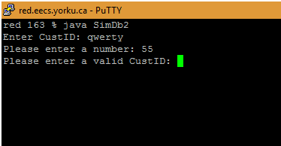

* When user enters a valid customer ID, customer information is displayed. Along with that, all the categories are also displayed as a list and user is then asked to enter category number to select a category:

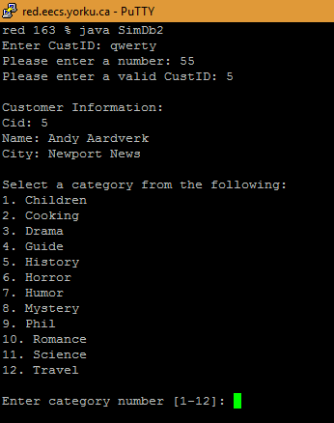

* User is now asked to enter a number to select a category. If he/she enters any invalid value, a message is displayed saying: “Please enter a number between 1 and 12” until a valid value is entered:

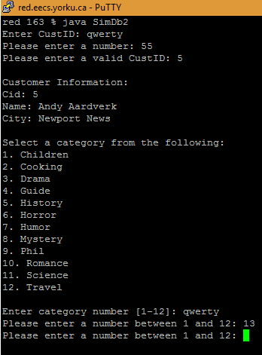

* When user enters a number in between 1 and 12 to select a category, all the book titles with the selected category is displayed.
* **Here, only those titles are displayed which are offered by the club that our user is a member of.**
* After displaying the titles, user is asked to select a book title by entering the corresponding number for the book. And if the user wants to change the category he’s asked to enter zero (0):
* If the user enters zero (0) then the list of the categories is displayed as before.
* And of course, the error checking is done, for example, if the user enters any invalid then proper error message is displayed and user is asked to enter again.

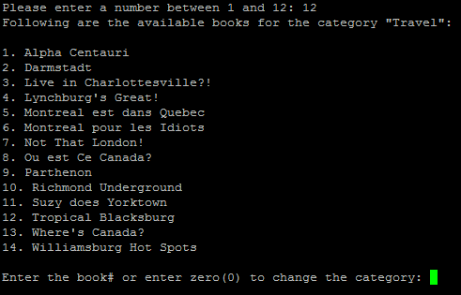

* Now, say user is interested in buying the book “Richmond Underground” then he enters the number ‘10’ and all the information of that book is displayed. Also, if there’s more than one book for the same title than all of them are displayed
* I added in my database two books with same title ‘Richmond Underground’, just to demonstrate that my app works with multiple books.
* After the books information is displayed to the user, he is asked to select one from the list i.e., to write the corresponding book #.

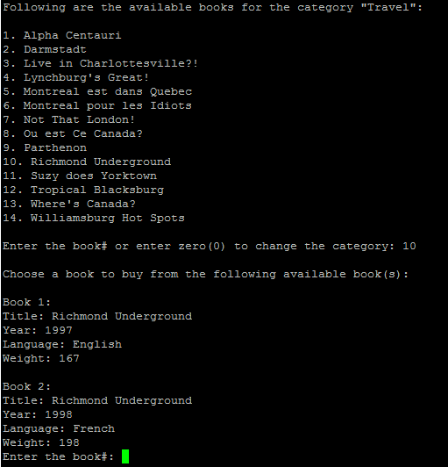

* Error checking is done if the user enters anything other than 1 or 2, since there are only two books to choose from. Let’s say user decides to select book number 2.
* When he enters “2”, the minimum price for that book is displayed. The minimum price is fetched only from the club in which the user is a member of. In other words, the cheapest price for the selected book from the clubs in which the user is a member of:
* After displaying the minimum price for a book, the app asks user to enter the quantity of that book to buy which must be greater than zero.
* When user enters the quantity of the books to buy, total amount is displayed i.e., quantity * price of the book
* And then he’s asked to confirm his order:

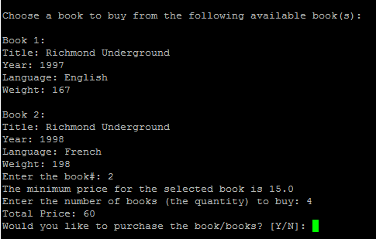

* To confirm the order, user must either enters ‘Y’ or ‘y’ for Yes or ‘n’ or ‘N’ for no. User is asked to enter again if writes something other than ‘Y’, ‘y’, ‘N’ or ‘n’.
* When user confirms the order, a message is displayed saying “Order placed, Thank You for buying from us” and the app closes:

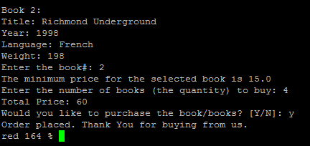

* And the information about the purchase is inserted into the table yrb_purchase with current timestamp, title, quantity, club, year and cid.
* The yrb_purchase table for the custID = 5:

